EVENT REPORT
Event Details
Event Title: The Art of Scientific Writing
Date: 07 Jan 2020
Time: 9.30am
Venue: LISSAH College,Kaithapoyil,Calicut

Event Poster

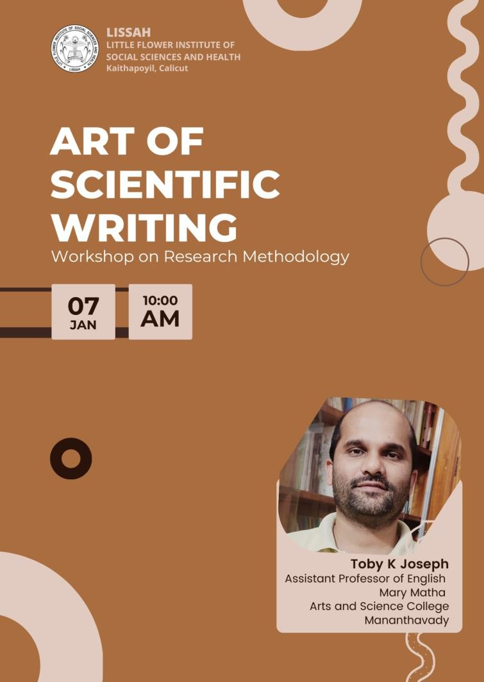

Event Report
A one day workshop on Research Methodology for UG and PG Scholars in the English Department was conducted on 07 January 2020 at the LISSAH College auditorium. The workshop was intended to disseminate knowledge relating to the methods and methodology in Social Sciences and Humanities research. The speaker Mr. Toby K Joseph (Assistant Professor of English,Mary Matha Arts & Science College,Mananthavady)delivered a technical session which dealt with the different aspects of research methodology. He was able to provide a systematic methodology by which the researchers can develop their research problem and focus on it.

Photos
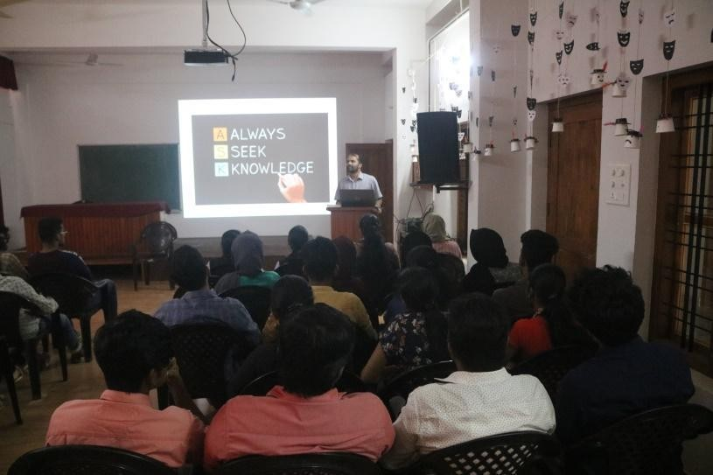

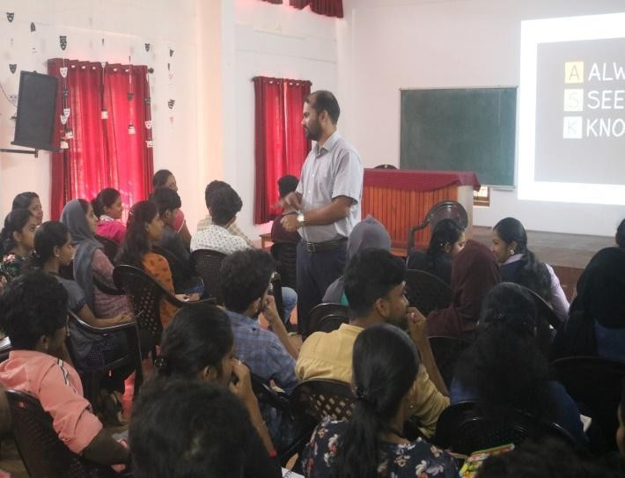

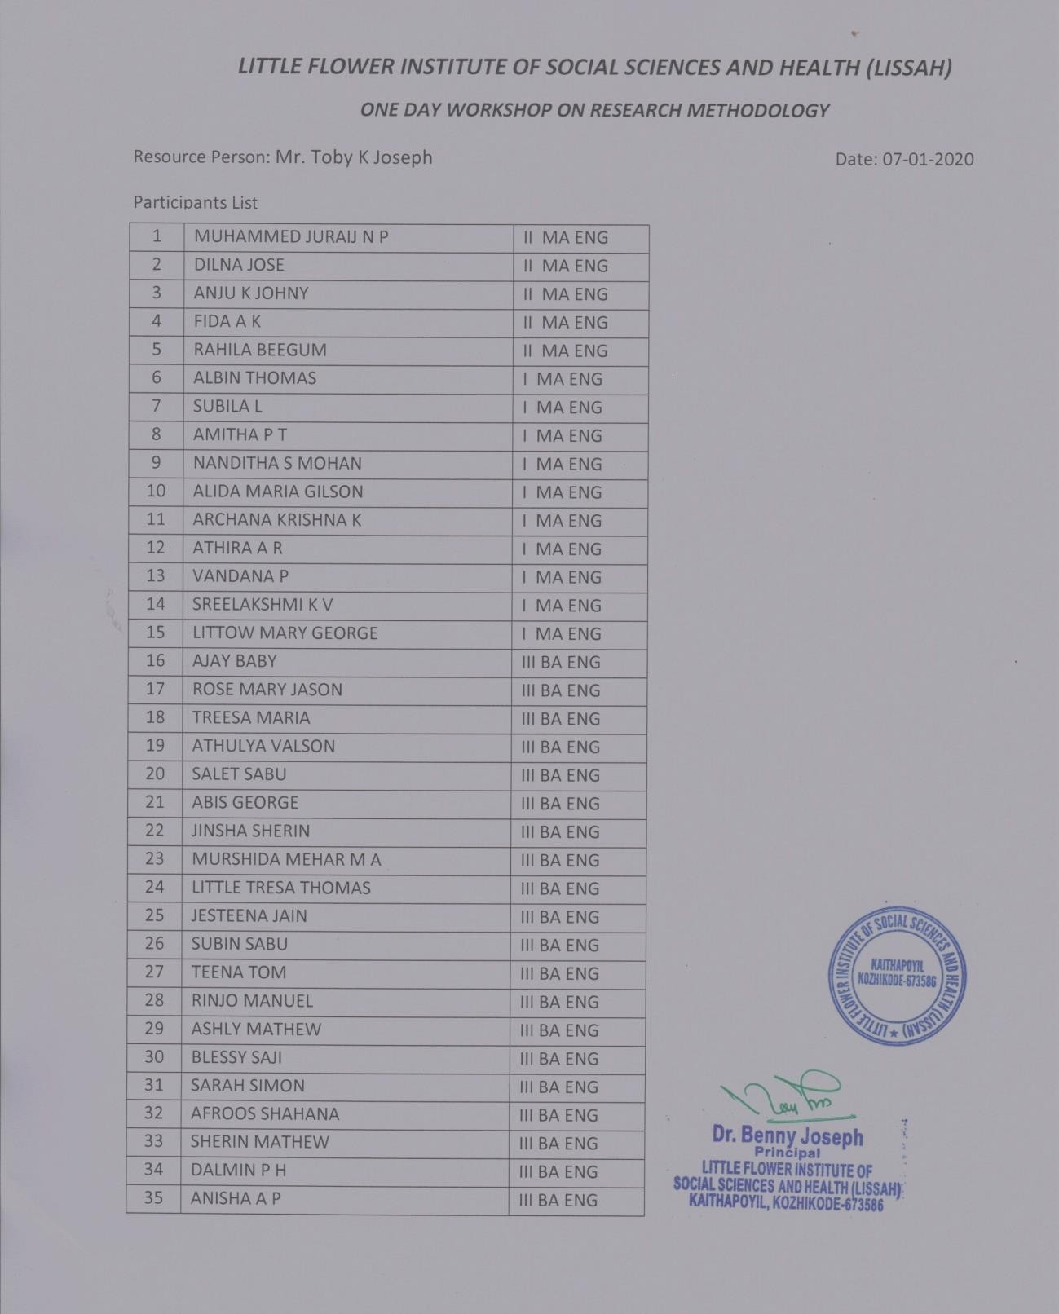
Attendance:

